**Task 1: Identifying the Top Branch by Sales Growth Rate (6 Marks)**

Walmart wants to identify which branch has exhibited the highest sales growth over time. Analyze the total sales for each branch and compare the growth rate across months to find the top performer

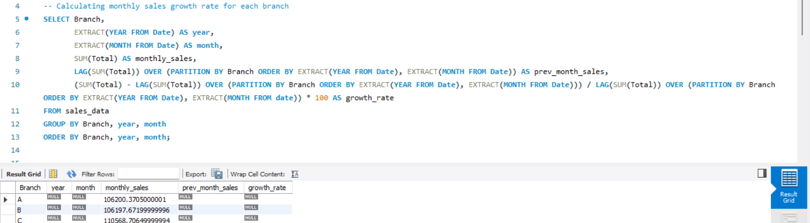

**Task 2: Finding the Most Profitable Product Line for Each Branch (6 Marks)**

Walmart needs to determine which product line contributes the highest profit to each branch.The profit margin

should be calculated based on the difference between the gross income and cost of goods sold.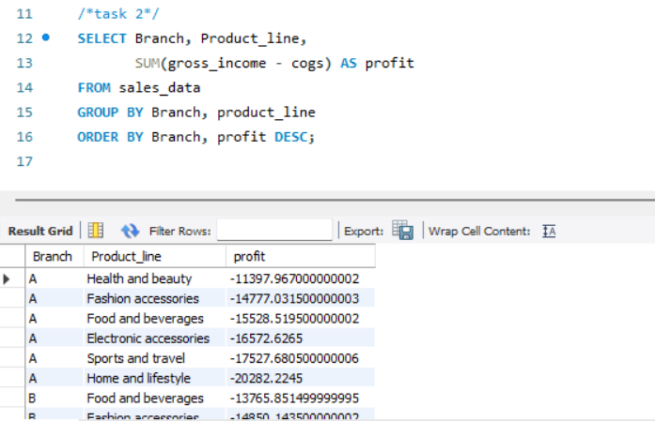

**Task 3: Analyzing Customer Segmentation Based on Spending (6 Marks)**

Walmart wants to segment customers based on their average spending behavior. Classify customers into three

tiers: High, Medium, and Low spenders based on their total purchase amounts.

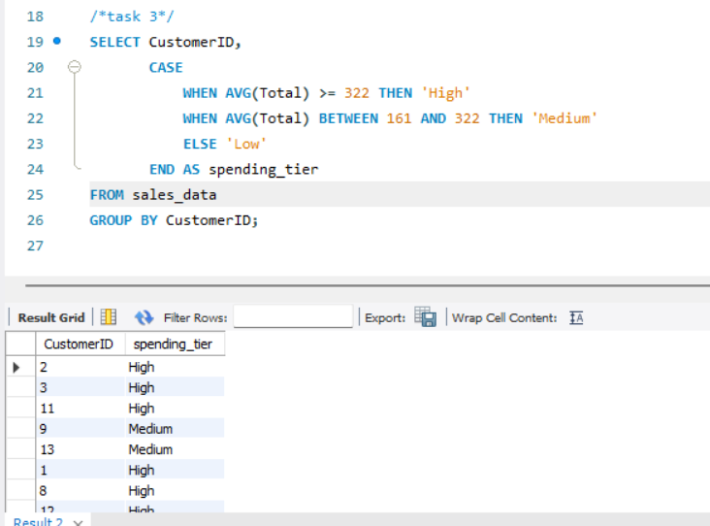

**Task 4: Detecting Anomalies in Sales Transactions (6 Marks)**

Walmart suspects that some transactions have unusually high or low sales compared to the average for the product line. Identify these anomalies.

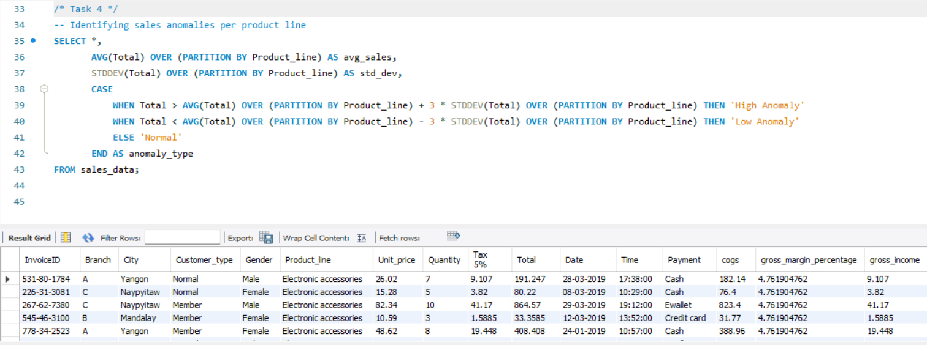

**Task 5: Most Popular Payment Method by City (6 Marks)**

Walmart needs to determine the most popular payment method in each city to tailor marketing strategies.

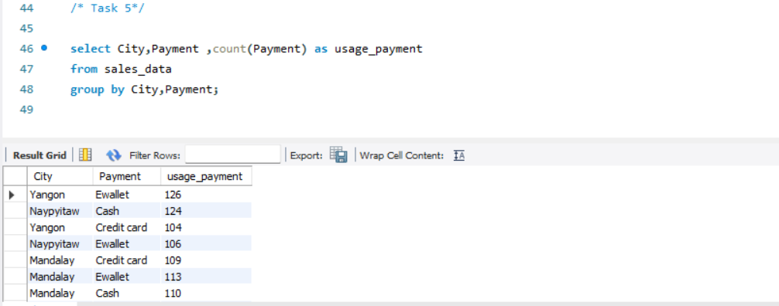

**Task 6: Monthly Sales Distribution by Gender (6 Marks)**

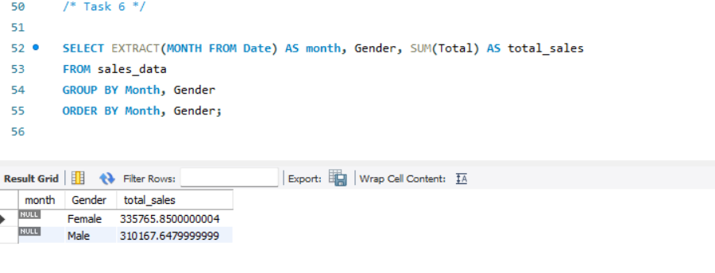Walmart wants to understand the sales distribution between male and female customers on a monthly basis.

**Task 7: Best Product Line by Customer Type (6 Marks)**

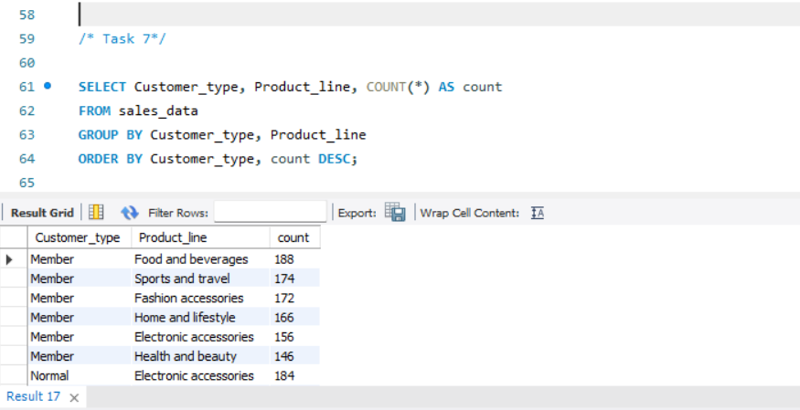Walmart wants to know which product lines are preferred by different customer types(Member vs. Normal).

**Task 8: Identifying Repeat Customers (6 Marks)**

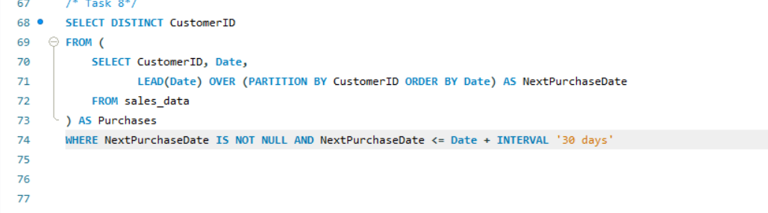Walmart needs to identify customers who made repeat purchases within a specific time frame (e.g., within 30 days).

**Task 9: Finding Top 5 Customers by Sales Volume (6 Marks)**

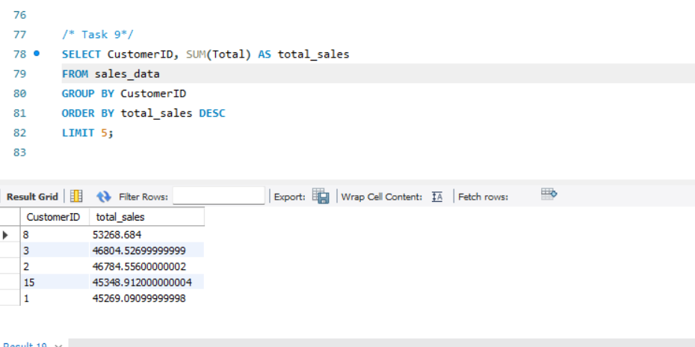Walmart wants to reward its top 5 customers who have generated the most sales Revenue

**Task 10: Analyzing Sales Trends by Day of the Week (6 Marks)**

Walmart wants to analyze the sales patterns to determine which day of the week brings the highest sales.

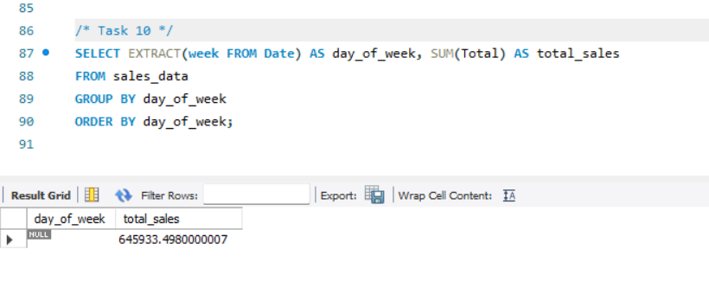

**LINK TO VIDEO PRESENTATION**

https://drive.google.com/file/d/1LrRZiui7TfdwwxkqVeyjZW71ficHY15H/view?usp=sharing